

**CHRISTERIA Mobile App**

**(UI Design Documentation)**

BACHELOR OF TECHNOLOGY IN COMPUTER SCIENCE AND ENGINEERING

BY

**AYUSH KUMAR (1761024)**

**TADEPALLI SURYA SASANK (1761018)**

**BHARATH S. (1761036)**

Department of Computer Science and Engineering

School of Engineering and Technology

CHRIST (Deemed to be University)

Kumbalagodu, 560074

July 2020

**1) Introduction:**

**a) Christeria:**

We are going to develop an application for the college canteen in which students are able to view the menu of all the four canteens and they can order according to the menu. And students can collect their order according to the order number or scheduled time.

1)For these, we are developing two applications in which the admin will have a separate app and students will be having another application.

2)In the admin app, canteen owners can edit their menu accordingly. And items that the admin will add automatically display in the student application.

3)And the layout or UI of both the apps will be similar to minor changes or few additional features in the Admin application.

With the help of this application, students can easily view the menu of each canteen and they can order their food. And students will get notifications if something special is added in the menu, If a person orders his food he will get a unique id and the admin will have the same id according to that canteen owner can manage the items ordered by the users. And here we use authentication of each user using his login so the orders can be easily managed and maintained in a database.

**b) Problem statement:**

In colleges and universities, there are many issues to be resolved. We are taking one of them i.e. issues related to serving food in canteens. In college canteens, students will be waiting in queues to order their food and wait till the food is prepared and then get the food. A lot of time is wasted in this process. If there is an app that helps in ordering food and collecting at the time that is mentioned, it would be saving time for students and the holders of the canteen. So, we are developing an application to order food which helps in ordering food and mentioning the time of delivery. The students can order food, select the pickup time. The holders of the canteen can mention the items that are available and process order. This app can solve the waiting time of students and the preparation time of canteen holders.

**c) Objective of the project:**

The objective of the project is to **make food prepared for the students by the time they reach the canteen.** When the students place the order, they will be mentioning the pickup time. The canteen holder can prepare the food and keep it ready for the students by the time they requested.

**2)** **Existing System**

There are many food delivering restaurants that are available in the market. Zomato, Swiggy are the systems that are used for people who can place delivery. Whereas Dominos, Pizza Hut are the systems that are used to place an order and eat in the restaurant itself or take away. But for students in college, who want to get their food from the canteen, our Christeria app will be perfectly suitable.

**3) Proposed work:**

**a) Software used to develop the project:**

We are using **flutter** which is a cross-application development platform, which will be deployed for both android and iOS.

Tools/Software used:

1. Flutter
2. Android Studio/Visual Studio Code

**b) Programming Language:**

1. Dart Programming

**c) Description of each module:**

Here I am considering each component as a module or each screen as a module.

First Screen:

The first screen will be Splash Screen with a text ‘Christeria’ with small animations for 2sec.

Second Screen:

The second screen will be Login Screen where registered users can login or unregistered

Users can register and login.

Third Screen:

The third screen will be the actual screen where an app bar will be visible and a list of canteens appears in a grid view. And users can click on any canteen which takes them to the next screen.

Fourth Screen:

The fourth screen will be with items available in the canteen with an option to place an order.

Once on a successful order user will be greeted with a success alert window.

And In addition to that, there will be an app drawer in which users can edit their profile and they can add their profile image. And in this app drawer itself, there will be an option to Logout.

**d) UI design of each module:**

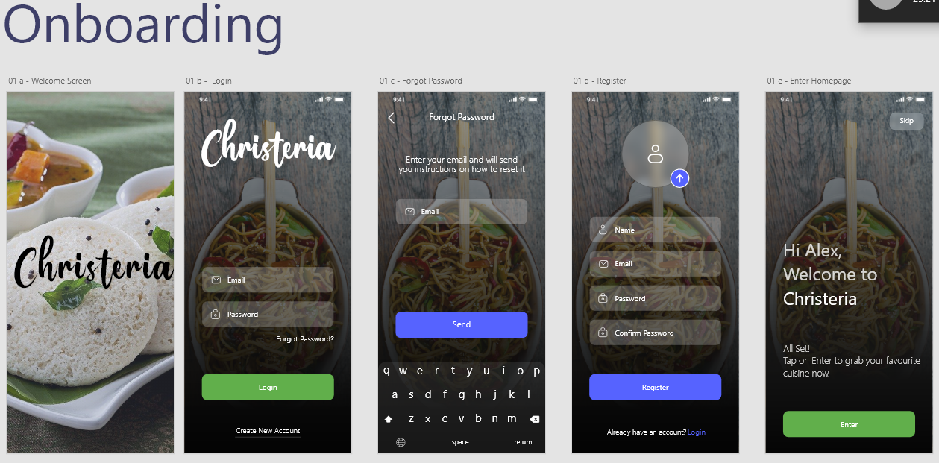

01 a - Welcome Screen - The first screen on application startup.

01 b - Login/Account Creation Prompt - The user can login if they have an account or register for a new account.

01 c - Forgot Password - In case the user doesn’t remember the password, he can tap on “Forgot Password?” and reset his password.

01 d - Registration - The signup form for a new user.

01 e - Account Creation Prompt - User is presented with this screen, upon successful account creation.

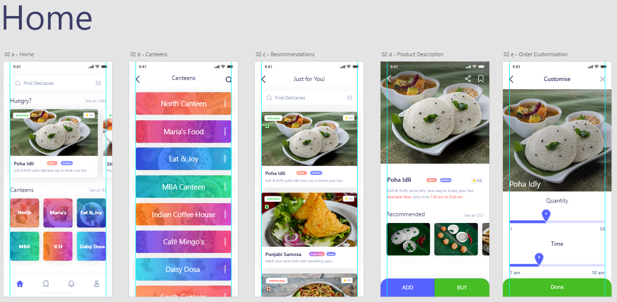

02 a - Home - The default screen of the app.

02 b - Canteens - The various canteens from where users can choose their food.

02 c -Just for you - Personalised curated delicacies according to the user’s taste.

02 d - Product Description - The details of the product before buying.

02 e - Order Customisation - The user can customize accordingly before placing the order.

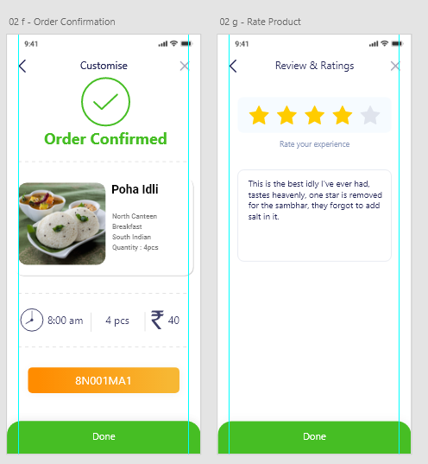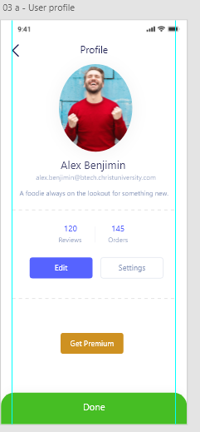

02 f - Order Confirmation - The user is greeted with a confirmation prompt upon successful order.

02 g - Rate Product - The user can rate the product based on his/her preference.

03 a - User Profile - The user can edit his/her personal information.

**e) Database Design and Database:**

The database that is used is Firebase. For authentication, we will be using basic authentication with only user login. And database design is different with two sections, where both the applications will be registered under one firebase account, where a non-relational database is used with all CRUD operations. Each order will be under user id with their order receipt number or order id. And each user will have a specific id.

The admin application for adding items will be under a different section with different cells.

From where all operations can be performed.

**f) Features of the project:**

1. Push Notifications-Users will receive push notifications regularly.

b) WIFI or Mobile data is compulsory to run the application.

**g) Screenshots of UI design:**

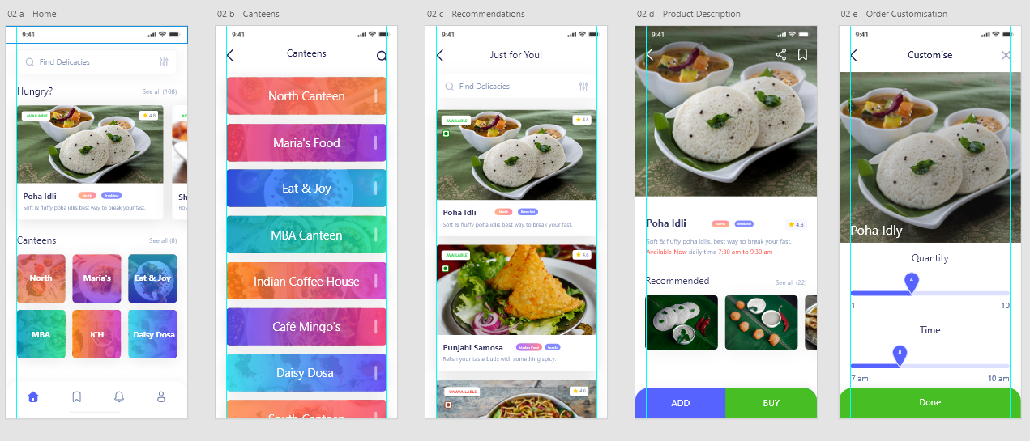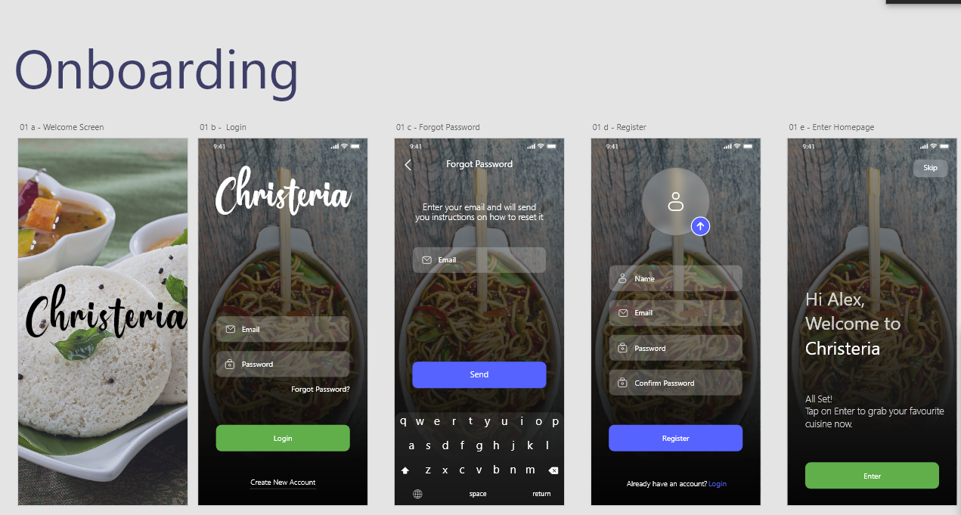

**4) Project Team Members:**

Ayush Kumar : 1761024

Bharath S : 1761036

Tadepalli Surya Sasank : 1761018

**5) Individual team members roles and responsibilities:**

Ayush Kumar : Design, Ideation, Wire-framing,

Development, Optimization.

Bharath S : Development Lead, Testing, Feasibility

Assessment, Deployment.

Tadepalli Surya Sasank : Major Development, Prototyping,

Documentation, Proof-Reading.